**INTRODUCTION**

The RESIN Maturity Assessment Model for Research IT and Research Support Functions is first and foremost designed to enable institutions to conduct an internal analysis of their Research Support across the different areas of the organisation that have a role to play.

The scope of the model centres on IT functionality – capabilities and requirements – as a nexus for what is included: what supports are required for effective Research IT infrastructure, e.g., funding, and what services are reliant on that infrastructure and services, e.g., research data management.

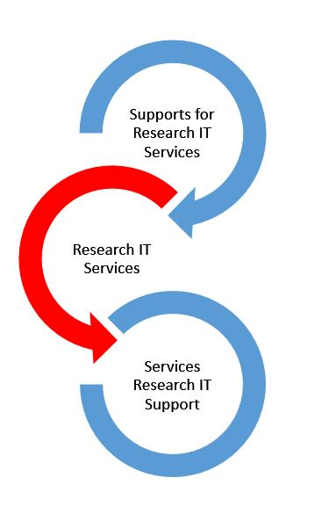

It is **not** designed as a tool to benchmark against other institutions/a nationally defined standard, but as an internal document to be used, amended, and adjusted as is suitable for your institution.

It is envisaged, however, that the model can be used by institutions to assess their position and any requirements relating to the goals outlined in IMPACT 2030 and the NORF National Action Plan for Open Research.

The following functional areas are included:

* Research IT Support Structure
* Research IT Funding
* Research Data Management Services
* Research Management

Capturing the capacity and capabilities of each of these areas is necessary, as all play a key role in achieving a high functioning Research environment. To that end, the model also seeks to capture the interaction between these functional areas, which we call ‘Governance and Coordination’.

While each functional area is delineated in the model, it is unlikely that each section can be answered by just one function, e.g., IT may be required to answer a question on archival storage solutions (which sits within the RDM model area). As such, we recommend the model is completed collaboratively.

Each capability can be ‘marked’ from Level 0 through to Level 3. There is also an option to select when something does not apply to your organisation – ‘Not Relevant’. Level 0 should be used when there is no service provided, but it *should* be and/or is planned for the service, whereas the ‘not relevant’ option should be taken where there is no plan or wish to provide this service; it is simply not a relevant question for you.

Each of the levels are described in terms of what a service at that level may look like. E.g.

|  |  |  |  |  |
| --- | --- | --- | --- | --- |
| **Function** | **level 0** | **level 1** | **level 2** | **level 3** |
| **Does your organisation deal with Data Governance within strategic documents and plans?** | No Open Research strategy. No RDM strategy. Open Research and RDM not mentioned in any institutional strategy documents. | Open Research mentioned and assigned actions in a wider institutional strategy without specific actions or targets for RDM/FAIR or Open Data. | Open Research called out in an institutional strategic plan wth dedicated actions to enable a FAIR/Open Data research environment. | Dedicated institutional Open Research Strategy which directly addresses FAIR/Open Data and RDM with targeted actions. |

It is likely that not all descriptions will match your organisation exactly; you may not provide something listed, but provide something that is not included, for example. A decision of where you believe the organisation to be at based on knowledge of the area and the aim for the service is an internal decision; the model is a supporting document in this regard. Similarly, a local decision may be required if a service is between two levels.

It may also be the case that your organisation provides a service to a certain level, but has no plans to extend it, i.e., ‘reach’ Level 3, and that you consider the service fully mature for your institutional purpose. As an internal document (and conversation), there is no expectation that Level 3 is the aim for all institutions in each case.

It is envisioned that by capturing what is currently in place, the outputs and outcome of the model will provide information on the following areas;

* A clear assessment the current service provision,
* An overview of service maturity level,
* Overview of integration, overlap and collaboration between services,
* Cross-functional research support workflows,
* Identification of duplication of effort, gaps or areas for improvement in the current offering,
* Identification and articulation of roles and responsibilities regarding Research Support.

And will provide the potential for these follow up actions to be considered where appropriate;

* An open conversation on Research Support with buy-in across the institution at all levels,
* A basis for a discussion between service and infrastructure providers and users,
* A roadmap towards a holistic service with next steps in future service development and inputs from key stakeholders,
* Create the potential for shared services and collaboration between central services,
* A collective voice when creating a business case for new services or resources.

Whether an institution chooses to produce a formal report with recommendations for future service provision, is an internal matter, but may be useful in advocating for services and developing a future roadmap.

Finally, the model is not designed to be exclusive and can be used in collaboration with other models, e.g. [RISE](https://www.dcc.ac.uk/sites/default/files/documents/publications/UsingRISE_v1_1.pdf), Capability Maturity Modelling. The RESIN model is envisaged to have a 3-year lifecycle, with a review to be completed and an updated model developed in 2027. This second iteration, envisaged to also have a 3-year lifecycle (to 2030), ties in with the timeline of the [IMPACT 2030 strategy](https://www.gov.ie/en/publication/27c78-impact-2030-irelands-new-research-and-innovation-strategy/), and will serve as a tool for institutional alignment to this strategy as relevant and appropriate.

**Insert case study here/usage example here.**